**INTEGRATION TESTING**

**IT_CASE 1:- CHECKING FOR WRONG PASSWORD**

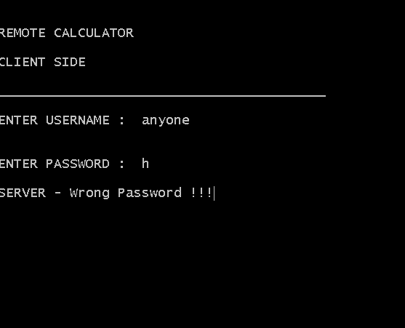

**IT_CASE 2:- CHECKING FOR VARIOUS ARITHMATICAL OPERATIONS:**

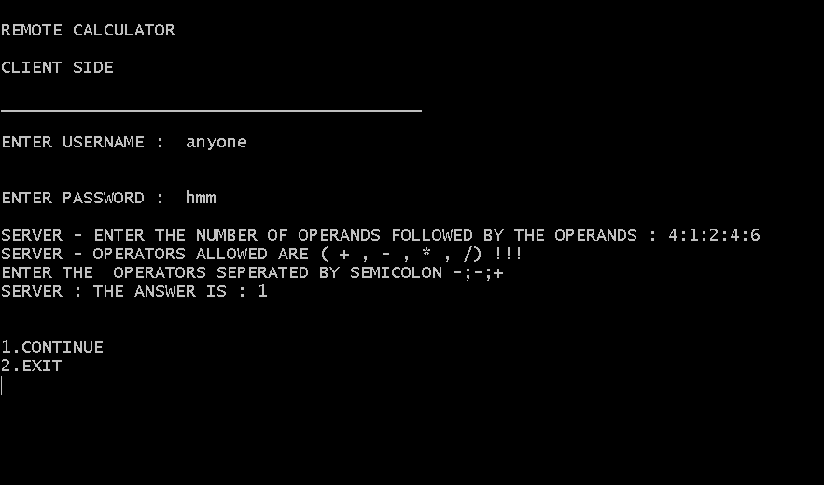

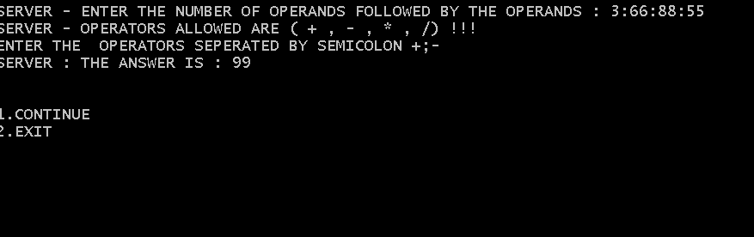

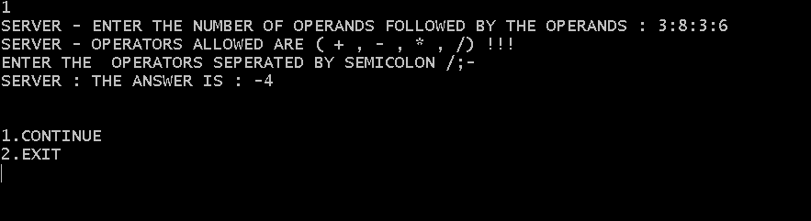

**IT_CASE 3:- CHECKING FOR WRONG FORMAT**

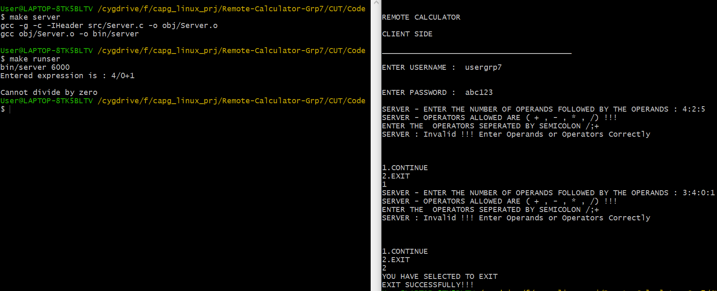

**IT_CASE 4:- OUTPUT ON SERVER SIDE**

